1. Imagen ms-participantes

<https://hub.docker.com/layers/mcabrerac/ms-participantes/1.0/images/sha256-8990c870a73cf539802e339261faacefcb07e5b6fff2a1ad84a6af02edf3803f>

mcabrerac/ms-participantes:1.0

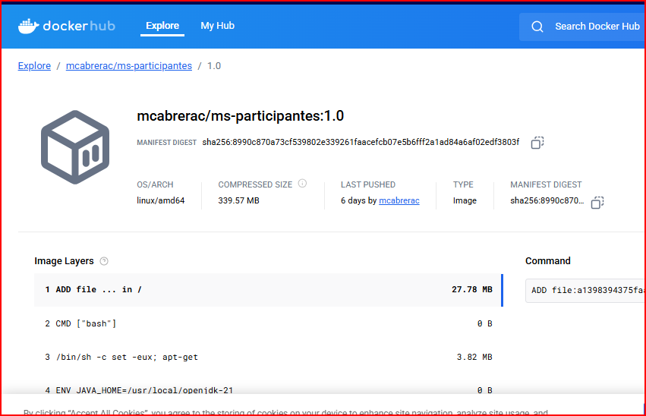

1. Imagen ms-eventos

<https://hub.docker.com/layers/mcabrerac/ms-eventos/1.0/images/sha256-8e49717ee77b40dfe238c72769e05aaa5d283474433ea1b8580b5a2a3c100384>

mcabrerac/ms-eventos:1.0

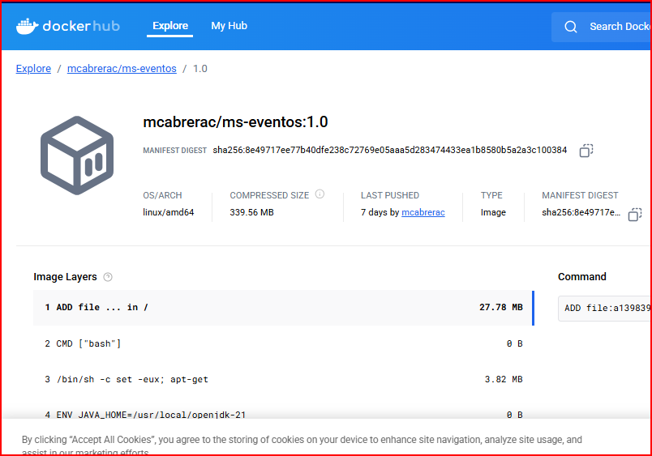

1. Imagen ms-gateway

<https://hub.docker.com/layers/mcabrerac/ms-gateway/1.0/images/sha256-297fcc72f7b2b9e6cf1c7a8b466184ea79330584b1e935b9eebbaa5c57d30a20>

mcabrerac/ms-gateway:1.0

